# COMP 7500/7506 - Lecture 11: Multilevel Queue Scheduling

**🟊: >85%, 🟊🟊: 70-85%, 🟊🟊🟊: 55-70%, 🟊🟊🟊🟊: 40-55%, 🟊🟊🟊🟊🟊: < 40%**

**🟊 Exercise 1 (Menti):** If a scheduler offers an average turn-round time of 20 second, what is the throughput of this scheduler?

1. 0.5 No./Second
2. 0.05 No./Second
3. 0.5 Second/No.
4. 20 Second/No.

**🟊🟊 Exercise 2:**

(2.1) Please propose two separate ready queues? (Hint: for different types of processes).

(2.2) What are scheduling policies these two queues?

**🟊 Exercise 3:** In multi-level queue scheduling, which queue has the highest priority and which queue has the lowest one?

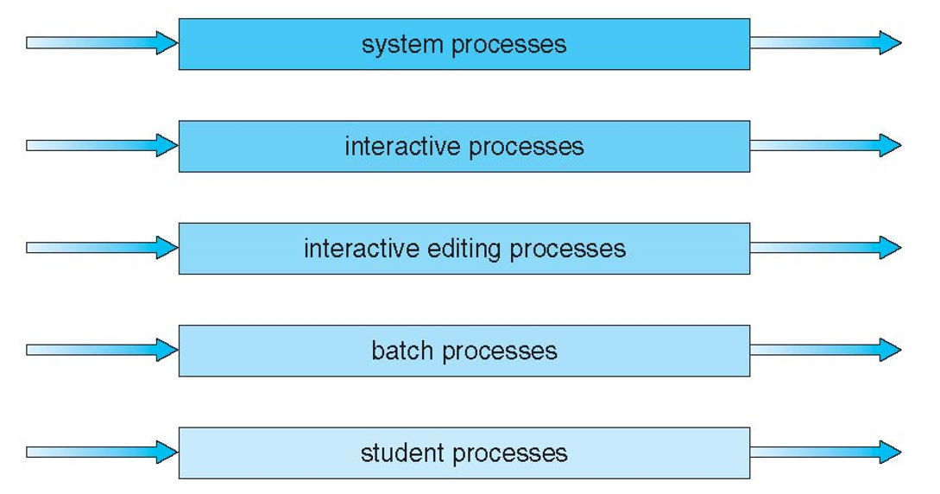

**🟊🟊 Exercise 4:** How to schedule between the two queues (i.e., interactive queue and batch queue)? (1 Minute)

**🟊🟊 Exercise 5:** Please setup the following parameters for a multilevel-feedback-queue scheduler.

* The number of queues: ________________
* Scheduling algorithm for each queue? Yes or No
* Method used to determine when to __________ a process
* Method used to determine when to __________ a process
* Method used to determine __________ a process will enter when that process needs service

**🟊🟊 Exercise 6 (Menti):** In the multilevel-feedback-queue scheduler, which queue has the highest priority?

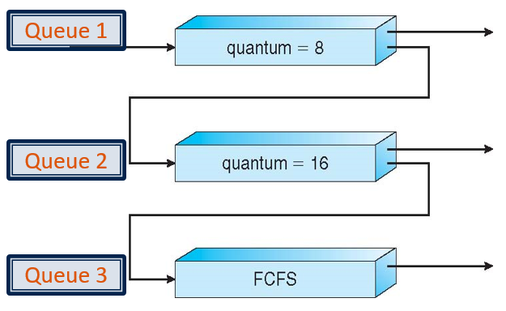

1. Queue 1
2. Queue 2
3. Queue 3
4. Queue 1 and Queue 3

**🟊🟊 Exercise 7 (Menti):** Which one of the following statement about the multilevel-feedback-queue scheduler is incorrect?

1. Processes in Queue 1 may starve
2. Processes in Queue 2 may starve
3. Processes in Queue 3 may starve
4. Some processes may starvation

**🟊 Exercise 8:** Please propose a solution to the problem described in Exercise 7.